# Little SPARK: Simple Play Adaptations to Reference for Kids

## Busy Box Alternatives: Compact Activity Center

**Materials:** The Compact Activity Center has a bead curtain, a vibrating light-up plate, a music box activated with a pull ball, and a spinning dome of brightly-colored sequins which helps with developing cognitive skills, teaching cause and effect, and increasing sensory stimulation.   
Requires 2 C Batteries. Weight: 3½ lbs.

**Image:**

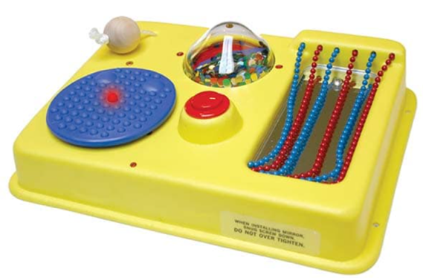

[Purchasing Information](https://enablingdevices.com/product/compact-activity-center/)

[Users Manual](https://enablingdevices.com/wp-content/uploads/2017/09/2300.pdf)

**Why Might Benefit?**

Those who need to further develop reaching, targeting, hand eye coordination, and fine motor skills.

**Why Use?**Provides an opportunity for simple cause and effect, multi-sensory engagement through reach and fine motor skills.

|  |  |
| --- | --- |
| **Instructions for Use:** | **Adaptation Ideas:** |
| **Environmental Considerations**   * Use anywhere but quiet areas may be disrupted.   **Positioning**   * Tabletop, floor (tummy or sidelying), wall-mounted with hardware (not included).   **Alternate Positioning**   * Slanted: Place on slanted surface such as a 3-4 inch 3 ring binder to help with viewing and reach.   **Basic Play/Use**   * Place in front of the child within easy reach for free exploration.   **Extended Play/Use**   * Give instructions:   + Touch the beads   + Press the blue button   + Touch the bumpy button   + Touch the one that makes music   **Play/Use with Others**   * Multiple items allows at least 2 children to play together for turn-taking turns or parallel play. | **Stabilize It**   * Dycem or velcro could be use on the back of the Activity Center.   **Simplify It**   * Cover choices to reveal one at a time.   **Add Sensory Cues**   * Stickers, puffy paint, or other tactile cues could be added if needed.   **Communication Support**   * Provide a communication board with vocabulary related to the various Activity Center activities.   **DIY Alternatives**   * [Build a toddler busy board with items you already have](https://www.familyhandyman.com/article/build-a-toddler-busy-board-with-items-you-already-have/). |

### Words to Encourage Play/Use

|  |  |  |
| --- | --- | --- |
| **Push**  Child pushing rock away. | **Pull A child pulling a rock toward them.** | **Reach**A child reaching for a red cube. |
| **Touch**A child with their hand on the shoulder of another child. | **Help**A child kneeling on his knee and another child reaching toward the kneeling child. | **LikeA hand giving a thumbs up** |
| **StopRed light lit up on a traffic signal** | **GoGreen light lit up on a traffic signal** | **MoreA pile of red stones with a black arrow pointing to the top and a smaller pile of red stone next to that pile.** |

*”Adaptations” adapted from: Haugen’s Modes for Adapting Toys based on materials from the "Let's Play" Project at the University of Buffalo

***PCS is a trademark of Tobii Dynavox, LLC.  All rights reserved.  Used with permission.***

